Subitising Ranger Test | Doubles Ranger Test | Counting 1-20 Ranger Test | Writing Ranger Test | Tens Mate M Ranger Test | More or Less Ranger Test
Recognising a number of objects, up to 5, with no counting.  Example:  Able to identify without pointing or counting.  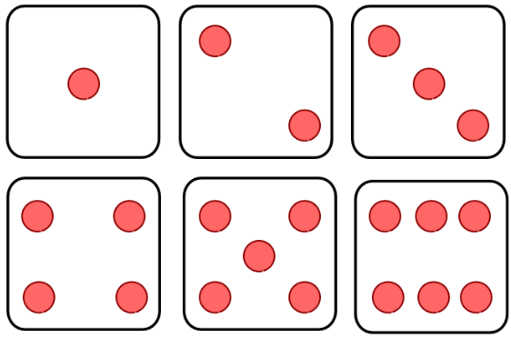 | Knowing double facts from 1-10.  Example:  Double 5 =  Double 8 =  Double 3 = | Being able to count from 1-20.  Example:  Give students a random pile of objects less than 21. They have to count them correctly. | Writing numbers for  0-20 correctly.  Example:  Students must write the numbers from 0-20 in order with no reversals of numbers. (5 as S or 2) | Knowing pairs of numbers that  add to 10.  Example:  Students need to respond with autonomy what number goes with the other to make ten.  7 and….  4 and… | Knowing 1 more and 1 less than for numbers up to 20.  Example:  Written or verbal. Students need to respond to one more than or one less than a chosen number less than 21.
Ideas:  Use dice with dots for board games.  Remind your child that they don’t always need to count they can use their eyes.  Guess how many things there are and then count them. | Ideas:  Use playing cards for games like snap.  Students need to add the matching cards and say correct answer in order to keep the pile.  Ask doubles questions in the car whilst driving, whilst walking to school, whilst cooking dinner, etc. | Ideas:  Practise counting whenever possible.  Counting things whilst out shopping, whilst walking or driving.  Read books that include counting. | Ideas:  Write numbers and have your child trace over them.  Have a number line present in a popular place in your home so your student can visual see the way numbers are written. | Ideas:  Play games like snap where numbers add to ten in order to collect the pile.  Roll a dice and instead of saying the number rolled students need to respond with what can be added to the rolled number to equal 10. | Ideas:  Practise counting forwards and backwards.  Write the numbers 0-20 and then cover some over. Ask what’s missing. Students  solve the question without counting.
Online Resources:  Dice Rolling:  http://www.curriculumbits.com/prodimages/details/maths/singledice.html  Lady Bug Counting:  http://www.topmarks.co.uk/learning-to-count/ladybird-spots  Gingerbread Man Counting:  http://www.topmarks.co.uk/learning-to-count/gingerbread-man-game | Online Resources:  Robin Hood Doubles:  http://www.ictgames.com/robindoubles.html  Double Bridge:  http://www.ictgames.com/bridgedoubles.html  Monkey Racer:  http://www.sheppardsoftware.com/mathgames/monkeydrive/addition/MDAddDoubles.htm | Online Resources:  Count Along:  http://resources.hwb.wales.gov.uk/VTC/ngfl/ngfl-flash/numbers_eng/numbers_e.html  Balloon Pop:  http://www.sheppardsoftware.com/mathgames/earlymath/BalloonCount20.htm | Online Resources:  Count Along:  http://resources.hwb.wales.gov.uk/VTC/ngfl/ngfl-flash/numbers_eng/numbers_e.html  Balloon Pop:  http://www.sheppardsoftware.com/mathgames/earlymath/BalloonCount20.htm | Online Resources:  Ball Addition:  http://akidsheart.com/math/mathgames/addtoten.htm  Ghost Match (2player):  http://resources.oswego.org/games/ghostblasters2/gb2nores.html | Online Resources:  One More One Less(PPT):  http://parkfield.typepad.com/parkfield/2010/01/1-more-1-less-game.html  One or Two Less:  http://www.helpingwithmath.com/resources/games/target-what-number02/what-number02.html  One or Two More:  http://www.helpingwithmath.com/resources/games/target-what-number01/what-number01.html

